**Frontex hosts conference on biometrics in Warsaw**

2019-10-09

This week, Frontex, the European Border and Coast Guard Agency, hosts a conference on the use of biometrics at the borders. This year, the conference focuses on the growing challenge of the use of morphed images of faces in identification documents to fool officials and computer systems.

The *International Conference of Biometrics for Borders*brings together experts and practitioners to discuss the various challenges and opportunities related to the use of biological or physical characteristics to identify individuals by law enforcement authorities.

“In today’s world we can no longer rely solely on traditional means of border control to assure a steady flow of travellers across borders and protect the security of our citizens at the same time,” said Frontex Executive Director Fabrice Leggeri.

“One of the key tools for the border guard authorities, of course, is new technology, especially biometric solutions. The right biometric solutions can have the power to allows genuine travellers to cross borders more smoothly, while allowing law enforcement authorities to identify potential threats more efficiently,” he added.

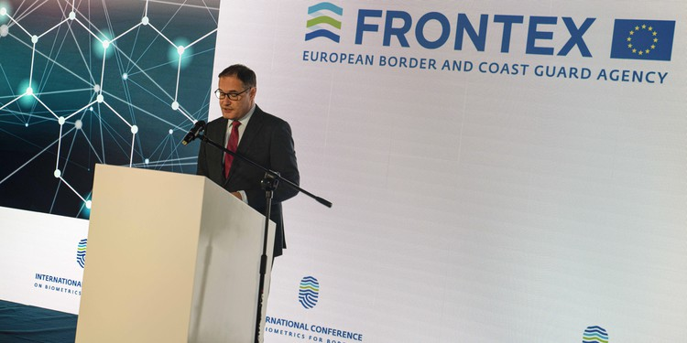

Frontex aims to identify and share information about the latest technology for the use of border guard authorities of EU countries, connecting them with researchers and industry representatives developing tools for more secure and effective borders. It also seeks to identify the latest challenges to border control, such as morphing of photographs in travel documents.

During the conference, participants will discuss the growing importance of biometric technologies to border management, and the implications of morphing for border control and possible actions aimed at mitigating this threat, including ways to prevent, detect and defeat it.

The participants include representatives of the EU institutions and agencies, such as European Commission, Europol and eu-LISA and a number of international organisations including the International Organization for Migration (IOM), Organization for Security and Co-operation in Europe (OSCE), Interpol, International Civil Aviation Organization (ICAO) and International Centre for Migration Policy Development (ICMPD).